Maths:
Multiplication and Division – Children will learn to times and divide by 10 and 100 and use formal written methods.
Measures- Pupils will learn to find equivalent lengths, including KM and M and find the perimeter of different shapes.
Fractions– Children will convert, find equivalent and add and subtract different fractions.
Decimals- Pupils will learn about tenths and hundredths. Our Parents’ Maths lesson will be held this term.

P.E: The children will learn different gymnastic moves to create a sequence.
Science:
Electricity – During this unit, children will learn about:
- Electrical appliances and safety
- Electrical components in a circuit
- Conductors and insulators
- Electrical switches
- Electricity and Safety
They will also complete a practical Investigation around electrical circuits.

English:
SPAG- The difference between plural and possessive –s Fronted adverbials (later that day, I ….) Appropriate choice of pronoun or noun Use of commas after fronted adverbials
Fiction – For our fiction writing we will be using the book ‘The tin forest’ by Helen Ward to write: a setting and character description and a diary entry

Non-Fiction – The children will take inspiration from their ‘Anglo-Saxons’ and ‘Tin forest’ units to write a non-chronological report and an explanation text.
Class Novel:
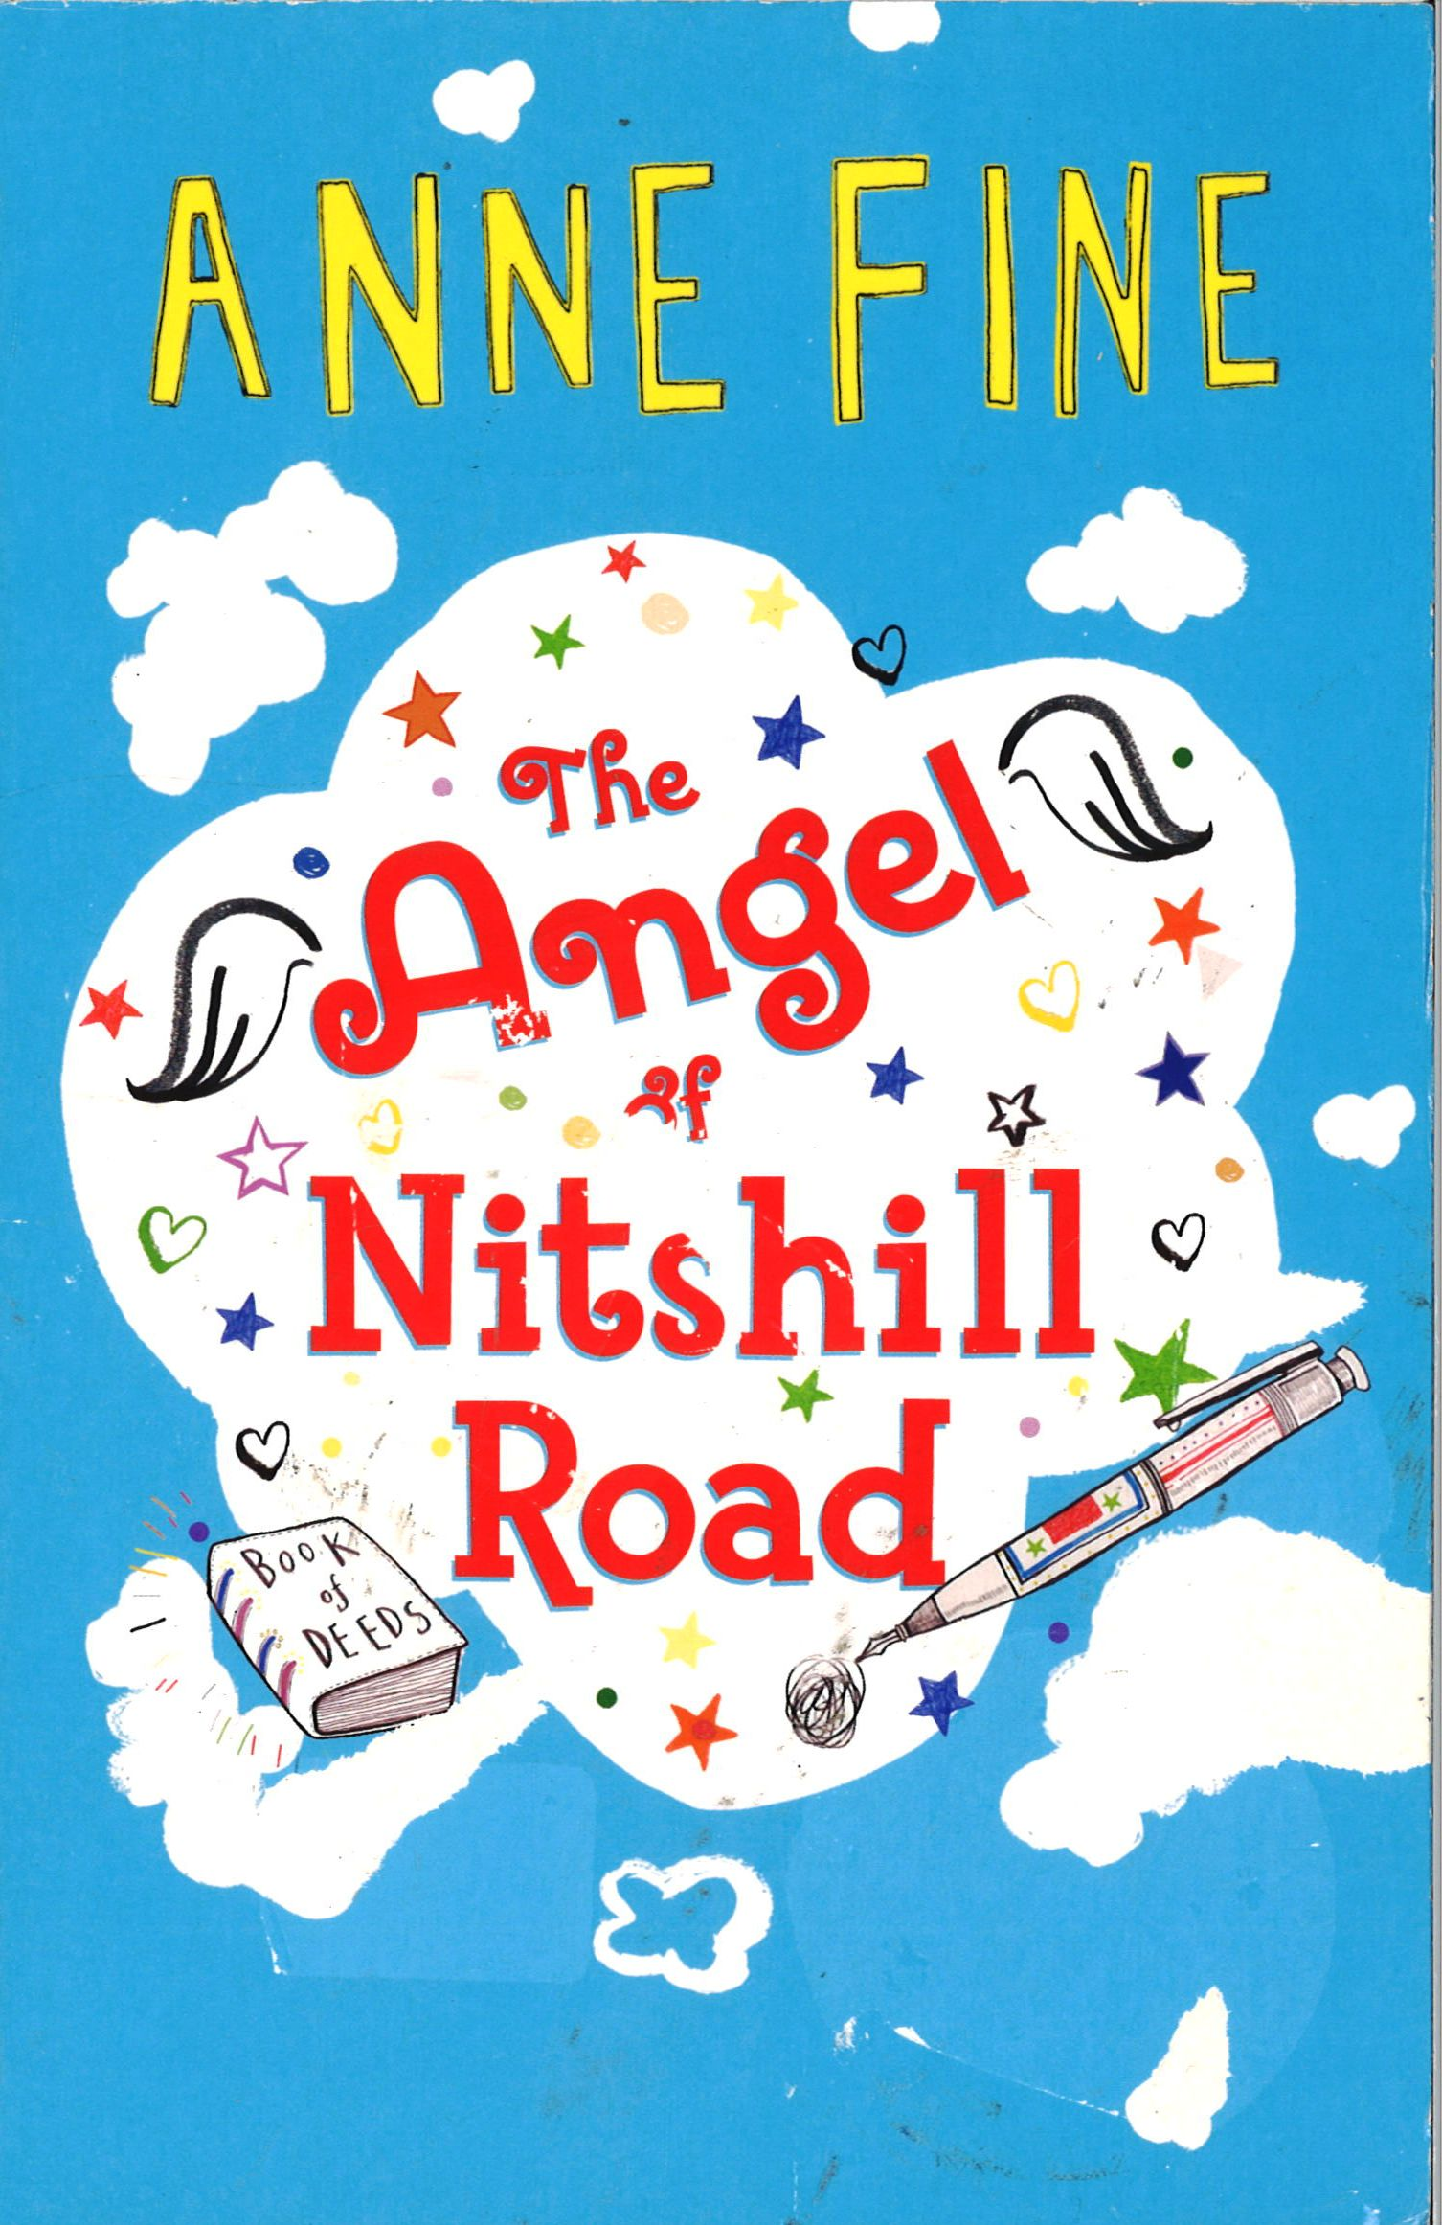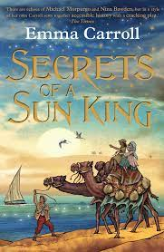
MFL - French
- My local area- how to say the names of important places.
- Body parts-naming and using body parts.
History/Geography
- Anglo -Saxons– Children will learn about where the Anglo-Saxons came from, what their villages were like, what they ate and drank and their links with Christianity.
- Erosion– Children will learn about the four types of desert, the process of erosion, how rivers are formed and erosion in national parks.

PSHE: Children will learn about keeping themselves safe.
Music: Musical instrument
The children will be learning new notes: C, high D and low E. In singing they will learn a new song: The doot doot song. ang‘shotgun’ on the recorder.
D.T / Art
* Art – Pupils will create 3d sculptures using tinfoil to create figures.
* D.T – The children investigate, design and build a fully operational alarm system. They will be going on a fieldtrip to Bolton Technical Innovation Centre to use their state-of–the-art technology.
Year 4 Spring Term
Overview
Mr Gavin
R.E and Celebration of the Word:
Branch 3- Galilee to Jerusalem- During this unit, children will learn to:
- Retell the visit of the Magi.
- Focus on the Kingdom of God through parables
- Show understanding of a miracle
- Learn about the Our father
- Celebration of the Word-each week, the children will work in small groups to plan and deliver their own Worship.
Reading:
- We will be reading a fictional novel called ‘The angel of Nitshill Road’ by Anne Fine.

Computing:
- Computer Science: Children will learn about digital footprints, respecting others online, online bullying and positives and negatives of technology.
- Digital Literacy – Children will continue learning touch typing and developing word processing skills, use spreadsheets and statistics to link with Maths.

