Come and Join us!



**IDL KS2 Parents workshop on Wednesday 16th October at 9am**

**This is for parents and carers of children in Y3, Y4, Y5 or Y6**

**Miss Postlewaite will be demonstrating how your child can access IDL at home for free to help them with their reading, spelling and maths skills.**

**Children who access IDL will be given a weekly prize and Miss Postlewaite will choose one child to be her IDL champion of the week.**

**Please come along to find out more!**

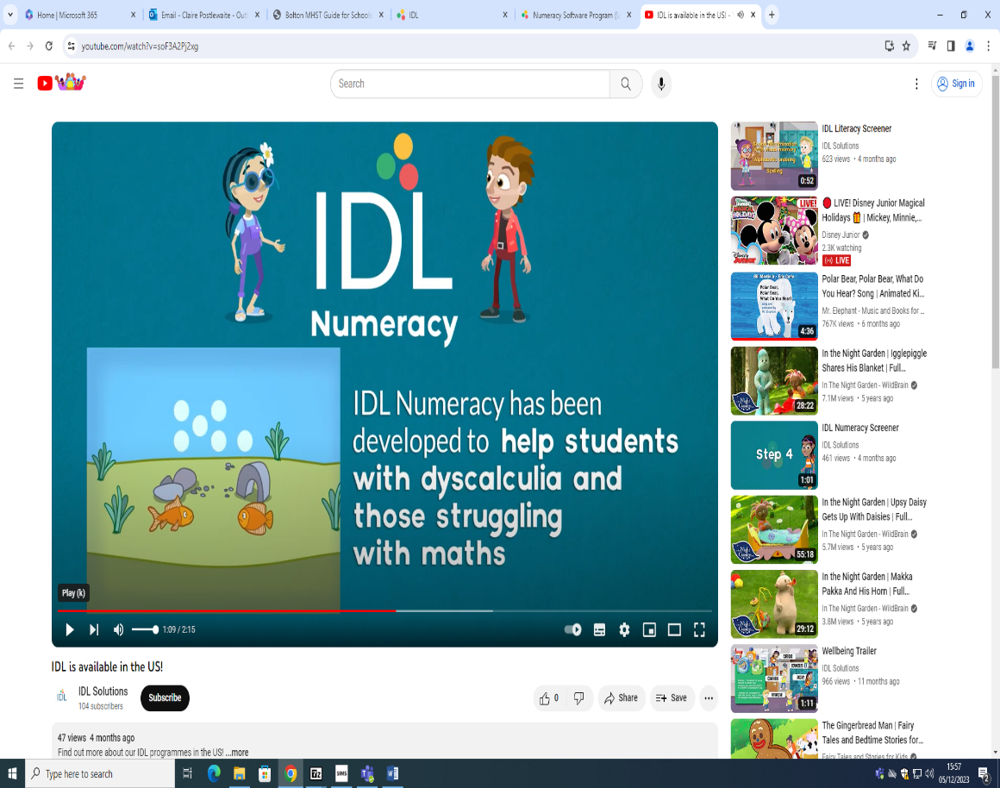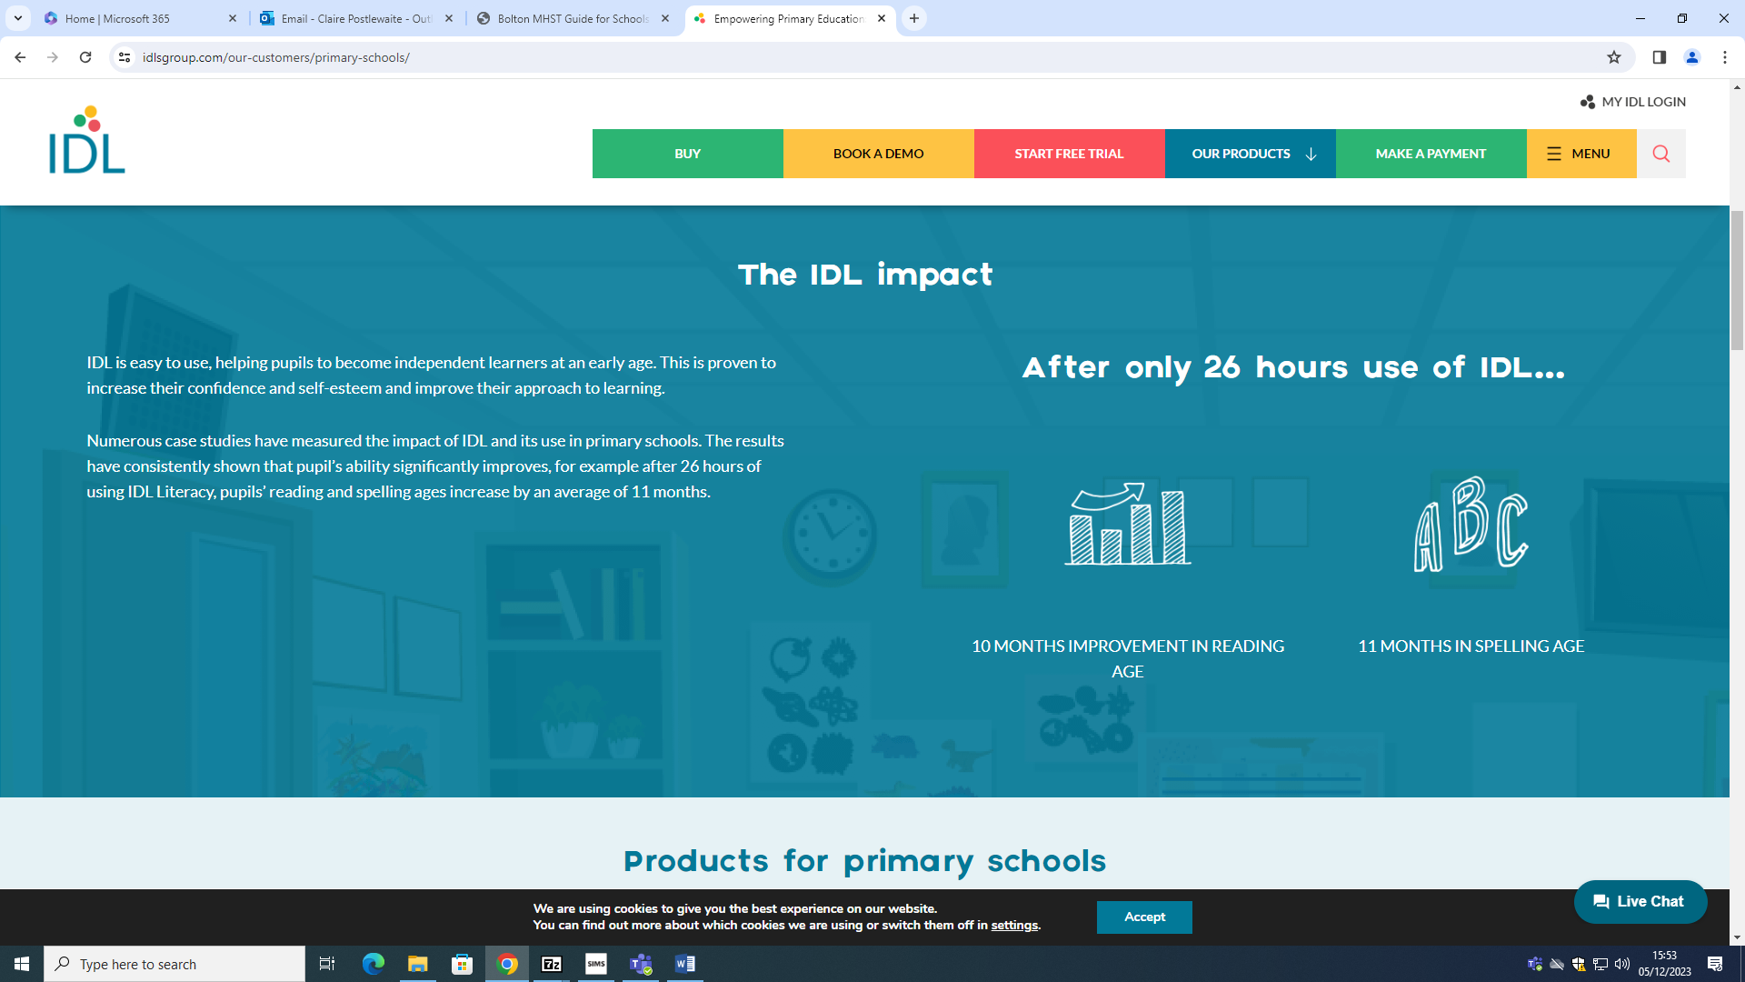

<https://idlsgroup.com/>