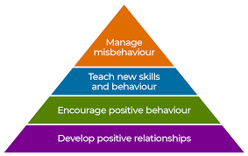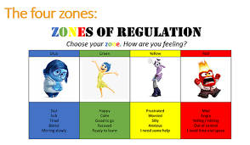

**We will be sharing top tips on how to manage behaviour positively at home.**

**Free hot drinks and snacks for everyone!**

**Thursday 10th October**

**8.55-9.45am**

**St. Ethelbert’s RCP School Hall**

**Come and meet our friendly professionals**

**Hosted by Miss Postlewaite our SENCO, Kathryn Stridgeon from Bolton Behaviour Support Service and Kelly Appleton from Bolton Mental Health and Well-being Service**

**parent coffee**

**morning**