**Seasonal/Topical activities**

**Our Local Area Eid**

**Transport Pushing and pulling**

**Pentecost – the Church’s Birthday**

**Maths**

**Addition and subtraction facts to 5.**

**Building numbers beyond 10**

**Counting patterns**

**Grouping and Sharing**

**More complex patterns**

**3D Shape – cylinder, cuboid, cube, sphere, cone, pyramid**

**RE**

**Topic 4 – Eucharist – gathering together in church – what will we see?**

**Pentecost**

**Multi-faith work – Islam and Judaism**

**Collective worship**

**Book of the Week**

**Mr Gumpy’s Motor Car**

**Oi, Get Off Our Train**

**The Three Little Pigs**

**Centipedes 100 Shoes**

**Three Little Vikings**

**On the Way Home**

**Visits and Visitors**

**Walk in Deane (shops etc)**

**Working with an artist**

**Hatching chicks**

**Summer 1**

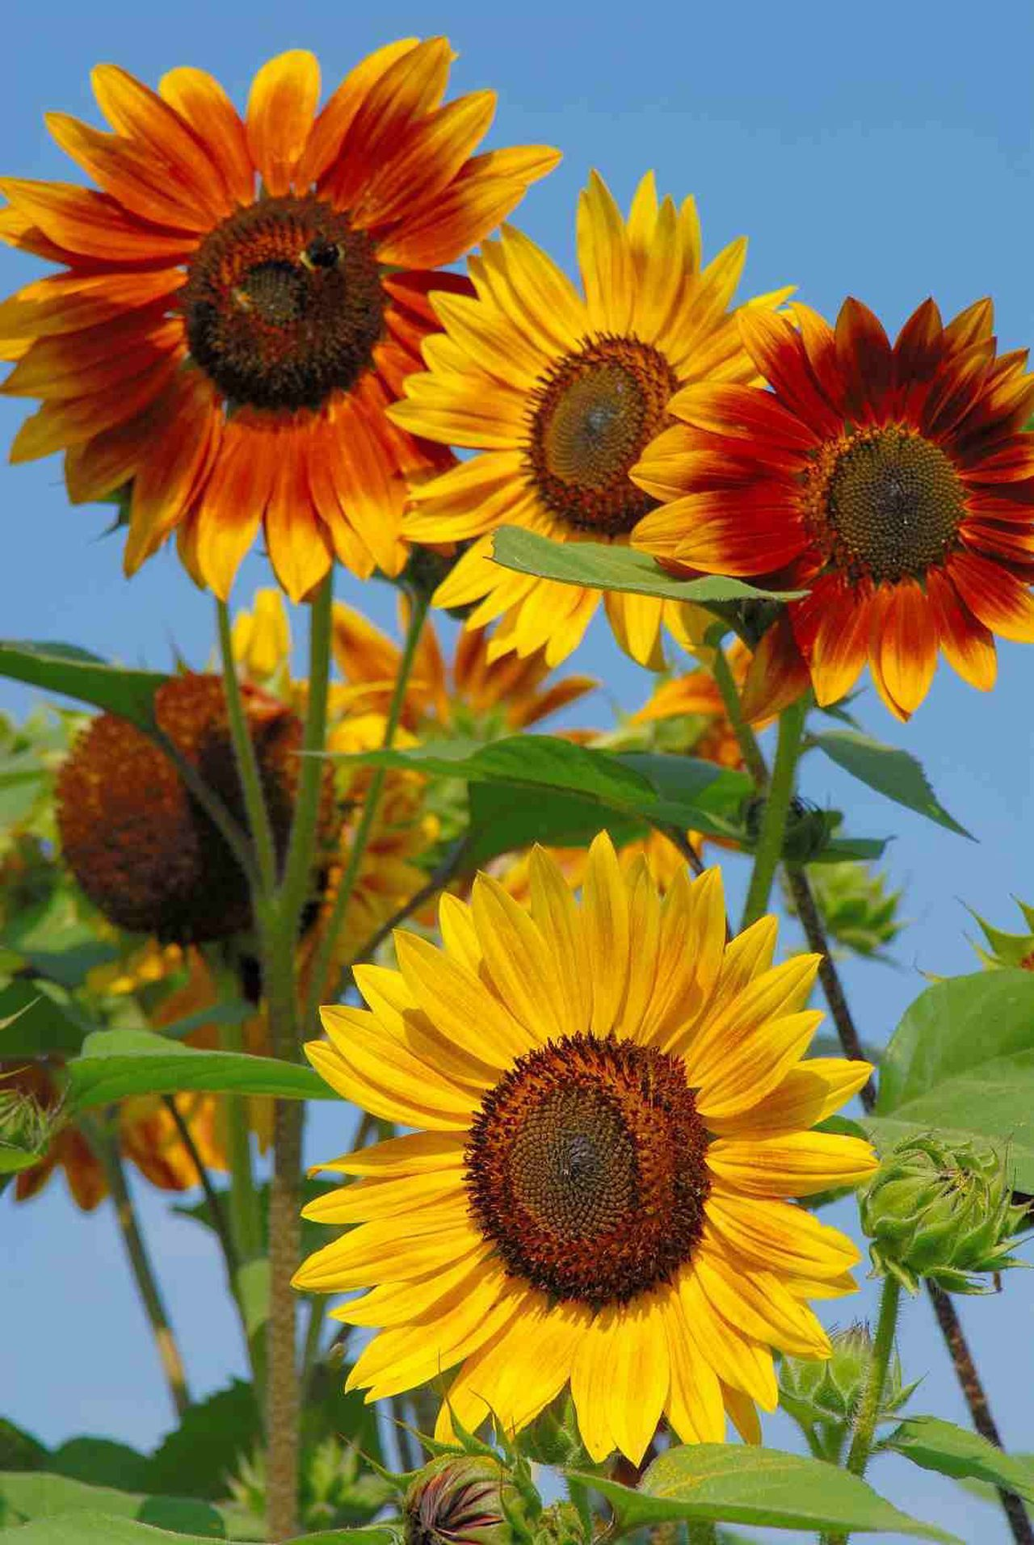

**What we will Learn About**

**Phonics**

**Letter names and Upper case letters**

**Consolidation of the Basics 3 and applying in reading and writing**

**The basics 4 ccvc/ccvc/ccvcc/cccvc**

**HF words – said like there so do little were when come some have one**