Year 3 and Year 4 Technology Agreement
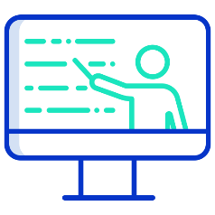  My Learning | - I will be respectful when I use a school device (PCs, laptops, tablets/ ipads) for my learning and tell a teacher if something is not working properly or I am struggling.  My School Accounts  - I will keep my usernames and passwords safe and secure - I will not share them.  - I will not use anyone else’s username and password.  - I will only use apps, programs, or websites that my teacher has told me to use.  - I will save only schoolwork on the school network.
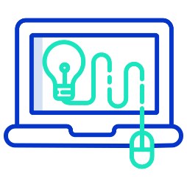  Using technology @school | My conduct as a Digital Citizen  - I know that I can talk to my teachers about my digital footprint and if I see content or somebody has made me feel sad, uncomfortable, embarrassed, or upset on the screen, I can tell them.  - I will respect other people’s work and property and will not access, copy, delete any other user’s files.  - I know that I should check the content on websites as not everything is real or true.
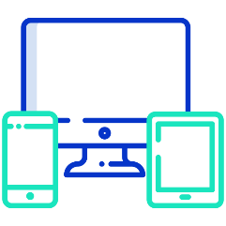  Using technology @home   | My online world content  - I understand that certain sites and games have age restrictions to keep me safe.  - I understand that by accessing such sites and games, I may be putting myself at risk of accessing inappropriate content and cyberbullying.  - I will tell a trusted adult if I see content or somebody has made me feel sad, uncomfortable, embarrassed, or upset on the screen.  My online world contact  - I will be aware that new friends made online may not be who they say there.  - I will be aware of what information cannot be shared between my friends.  - I will be polite and responsible when I communicate with others online.  - I will not use inappropriate language and I understand that others may have different opinions than me.  My online world conduct  - I understand that spending too much time online is not always good for me.  - I understand that content I share online can still be there even after I have deleted it.  - I will tell a trusted adult if I see content or somebody has made me feel sad, uncomfortable, embarrassed, or upset on the screen.  - With the help of a trusted adult I will report any inappropriate content, messages or anything that makes me feel uncomfortable online, using the app/social media reporting tool or other online support agencies e.g. CEOP, Childline, Barnardos.

- I understand that this agreement will help me to stay safe and I agree to follow these rules.
- I also understand that if I break the rules or behave inappropriately online in school, I may not be allowed to use the school’s computing equipment.

__________________________________________
Child’s Signature

