Year 1 and Year 2 Technology Agreement

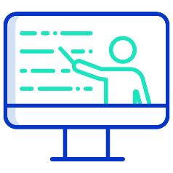  My Learning  Using technology @school  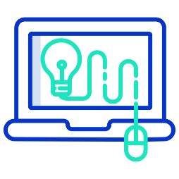 | My conduct as a Digital Citizen  - I will be respectful when I use a school device (PCs, laptops, tablets/ ipads) for my learning and tell a teacher if I am struggling or something is not working properly.  - I know I need to follow our online safety rules to help me keep safe and healthy online at school when using technology.  - I will only use activities that my teacher has told or allowed me to use.  - I will be kind online, so I do not upset my friends.  - I can talk about my digital footprint and will use what I have learned about Online Safety in school to search safety.  - I will tell my teacher if I see something or somebody has made me feel sad, uncomfortable, embarrassed, or upset on the screen.
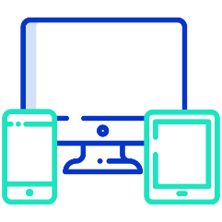  Using technology @home | My online world content  - I understand that certain sites and games have age restrictions to keep me safe.  - I understand that by accessing such sites and games, I may be putting myself at risk of cyberbullying.  - I will tell a trusted adult if I see content or somebody has made me feel sad, uncomfortable, embarrassed, or upset on the screen.  My online world contact  - Where I have my own username and password, I will keep it safe and secret.  - I will not share personal information about myself when on-line (names, addresses, telephone numbers, age, gender, school details)  - I will tell a trusted adult if I see something or somebody has made me feel sad, uncomfortable, embarrassed, or upset on the screen.
I understand that this agreement will help me to stay safe and I agree to follow these rules.
I also understand that if I break the rules, I may not be allowed to use the school’s computing equipment.

_____________________________________
Child’s Signature

