
Music @ St Ethelbert’s “Where words fail, music speaks.” Hans Christian Anderson

 | Autumn 1 | Spring 1 | Summer 1
Year 1 |  |  | 
 | Autumn Leaves | Countries of the UK | Pirates
Year 2 |  | 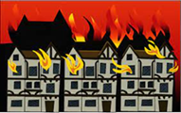 | 
 | The Ants Go Marching | Great Fire Of London | Circus
Year 3 |  |  | 
 | Earthquakes | Romans | Rainforests
Year 4 |  | 
 | Ukulele | Ukulele | Ukulele
Year 5 |  |  | 
 | Popocatepetl | Vikings | Heio
Year 6 |  |  | 
 | World War II – Waving Goodbye | Bubble-gum Rappers | Light

