
MFL @ St Ethelbert’s

 | Autumn 1 | Autumn 2 | Spring 1 | Spring 2 | Summer 1 | Summer 2
Year 3 |  |  | 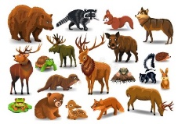 |  |  | 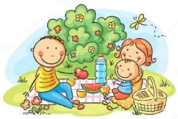
 | A New Start | The calendar and celebrations | Animals I like and don’t like | Carnival and playground games | Breakfast, fruit nouns and Hungry Giant | Going on a picnic/Aliens in France
Year 4 |  | 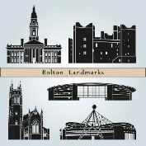 | 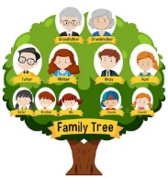 |  | 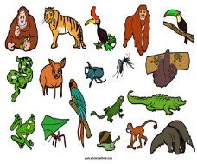 | 
 | Welcome to super school learners | My local area, your local area | Family Tree and faces | Celebrating carnival/body parts | Feeling unwell/Jungle animals | The weather/Ice Creams
Year 5 |  | 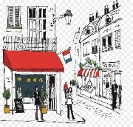 |  |  |  | 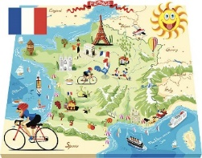
 | My school, my subject | Time in the city | Healthy eating-going to the market | Clothes, colours, fashion show | Out of this world | Going to the seaside
Year 6 |  |  |  |  |  | 
 | Everyday life | Where I Live, where you live | Playing and enjoying sport | This is me, hobbies and fun | Café culture and restaurants | Performance time

