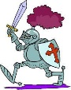
History @ St Ethelbert’s

 | Autumn | Spring | Summer
Year1 |  | 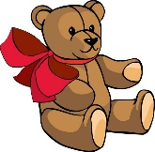
 |  | Toys
Year 2 |  | 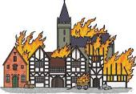
 | Great History Makers | Great Fire of London
Year 3 | 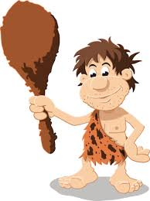 |  | 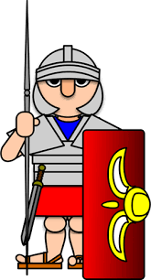
 | Stone Age |  | Romans
Year 4 | 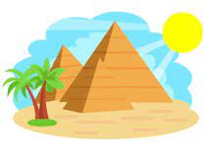 | 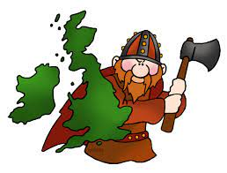
 | Ancient Egypt | Anglo-Saxons | Local History
 | Autumn | Spring | Summer
Year 5 | 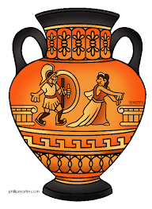 | 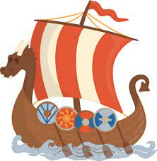
 | Ancient Greece | Vikings
Year 6 | 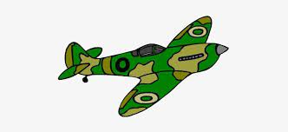 | 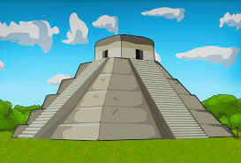
 | World War II | Maya Civilisation

