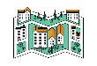
Geography @ St Ethelbert’s
Providing our children with a sense of awe and wonder about God’s world.
 | Autumn | Spring | Summer
Year1 |  |  | 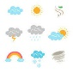
 | Our Country  Continents and Oceans Song |  | Weather
Year 2 |  |  | 
 |  | Why Don’t Penguins Need to Fly?  Locating Continents and Oceans | Why do we love being beside the sea so much?
Year 3 | 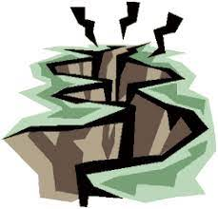 | 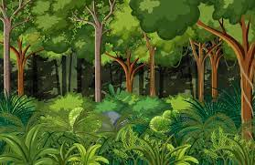 | 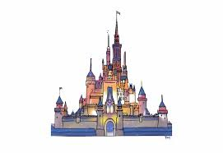
 | Earthquakes | Jungles and Deserts | Beyond the Magic Kingdom
Year 4 | 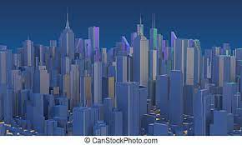 | 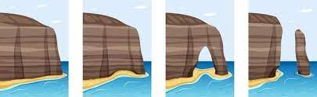
 | Mega Cities | Erosion
 | Autumn | Spring | Summer
Year 5 | 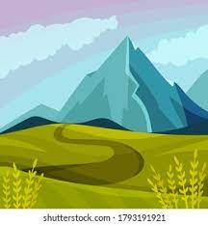 | 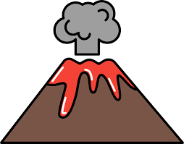 | 
 | Why are mountains so important? | How do volcanoes affect the lives of people? | How is climate change affecting the world?
Year 6 |  | 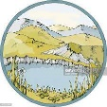 | 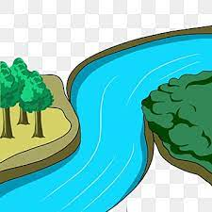
 | Why is Fairtrade fair? | Who are Britain’s national parks for? | What is a river?
Whole School: | 
Local Geography Week
(Fieldwork Focus)

